**14**

**Fluid Mechanics**

|  |
| --- |
| **CHAPTER OUTLINE** |

14.1 Pressure

14.2 Variation of Pressure with Depth

14.3 Pressure Measurements

14.4 Buoyant Forces and Archimedes’s Principle

14.5 Fluid Dynamics

14.6 Bernoulli’s Equation

14.7 Flow of Viscous Fluids in Pipes

14.8 Other Applications of Fluid Dynamics

* An asterisk indicates a question or problem new to this edition.

|  |
| --- |
| **SOLUTIONS TO THINK-PAIR-SHARE AND ACTIVITIES** |

**\*TP14.1.** Answers:(a) Regardless of the gas inside the football, as long as it is filled to the proper pressure, the football has the same volume. The buoyant force on the football from the air depends only on its volume, so the helium inside has no effect.

(b) The helium-filled football will be slightly less massive (about 1%) than the air-filled football, so the football with helium will be more subject to air resistance and wind. Both *Sports Illustrated* and *Mythbusters* have studied the helium-filled football and found that kicks and passes are *shorter* with the helium.

**\*TP14.2.** Let’s look at the first proposed activity: the student has the mouthpiece in his mouth and sinks to the bottom while breathing. The process of breathing begins when the chest muscles expand to reduce the pressure in the lungs, causing air to be pushed into the lungs by the atmosphere. When surrounded by air, the chest muscles only have to push against the air pressure surrounding the student. When he is surrounded by water, there is both the atmospheric pressure and the pressure due to the water surrounding the student. His chest muscles must push against the force due to both pressures underwater. Because his body is used to only having to push against the force due to atmospheric pressure, it has difficulty moving the chest outward against a larger pressure. It turns out that only about 0.6 m of water is enough to provide a pressure against which one cannot expand the chest. Therefore, as he sinks to the bottom of the pool, he will find that he cannot expand his chest to take a breath, and the long snorkel is useless. He will notice this as he sinks and will hopefully abandon the snorkel and swim to the surface.

Now, let’s address the *very dangerous* second activity, in which the student sinks to the bottom of the pool with the end of the snorkel closed and then puts it in your mouth. When he is surrounded by water at higher pressure than atmospheric pressure, his entire body is at a higher pressure. That includes the air in his lungs and his blood. The normal design of the lungs is that the higher air pressure in the lungs pushes oxygen into the lower pressure blood. When he puts the end of the snorkel in his mouth and releases the end, he suddenly has a connection to the atmosphere at the upper end, which is at a lower pressure than the air in his lungs. The high-pressure air in his lungs will suddenly rush up the PVC pipe, and his blood pressure will be higher than the air pressure in his lungs. The result is a *pneumothorax*: his lungs will collapse. If the pressure difference is large enough, blood will enter his lungs from the capillaries.

A related phenomenon occurs in scuba divers. If a scuba diver is rising from a deep dive, he or she *must* exhale as he or she rises. If not, the air pressure in the lungs stays fixed while the outer pressure on the body decreases. Because of this decreasing outside pressure, the diver’s blood pressure also decreases. As a result, the high pressure in the lungs can force air into the blood vessels, creating an *air embolism*: bubbles in the bloodstream. These bubbles can travel throughout the body, including to the heart, possibly leading to cardiac arrest.

Answers: Answers will vary, but have to do with the effects of high pressure on the human lung system.

**\*TP14.3.** (a) The effective density of the diet soda is slightly less than that of water because of the artificial sweetener. Think about a packet of sugar and a packet of artificial sweetener with the same “sweetening power.” The packet of artificial sweetener is lighter than the packet of sugar because the amount of the artificial sweetener needed to provide a certain “sweetening power” is lower than that for sugar. The amount of sugar needed to sweeten a soft drink is high enough that the effective density of the can–soda combination is slightly higher than that of water and the regular, sugar-sweetened soda sinks.

(b) Bubbles of carbon dioxide from the carbonation of the drink will adhere to the raisins. When enough bubbles adhere, the effective density of the raisin–bubble combination is less than that of the beverage, and the raisin rises to the surface. At the surface, the bubbles pop and the gas goes into the atmosphere. The now de-bubbled raisin sinks back to the bottom and begins gathering new bubbles, preparing to rise again.

*Answers:* (a) Diet soda floats; regular soda sinks. (b) Raisins alternately sink and float for several minutes after being added to the liquid.

|  |
| --- |
| **SOLUTIONS TO END-OF-CHAPTER PROBLEMS** |

Section 14.1 Pressure

**P14.1** We shall assume that each chair leg supports one-fourth of the total weight so the normal force each leg exerts on the floor is *n* = *mg*/4. The pressure of each leg on the floor is then



**P14.2** (a) If the particles in the nucleus are closely packed with negligible space between them, the average nuclear density should be approximately that of a proton or neutron. That is



(b) 

**P14.3** The Earth’s surface area is The force pushing inward over this area amounts to



This force is the weight of the air:



so, assuming *g* is everywhere the same, the mass of the air is



Section 14.2 Variation of Pressure with Depth

P14.4 We imagine Superman can produce a perfect vacuum in the straw. Take point 1, at position *y*1 = 0, to be at the water’s surface and point 2, at position *y*2 = length of straw, to be at the upper end of the straw. What is the greatest length of straw that will allow Superman to drink? Solve for *y*2:



1.013 × 105 Pa + 0 = 0 + (103 kg/m3)(9.80 m/s2)y2

or *y*2 = 10.3 m.



**P14.5** 

When the cup barely supports the student, the normal force of the ceiling is zero and the cup is in equilibrium.



**P14.6** The excess water pressure (over air pressure) halfway down is



The force on the wall due to the water is



**P14.7** The bell is uniformly compressed, so we can model it with any shape. We choose a sphere of diameter 3.00 m.

The pressure on the ball is given by  so the change in pressure on the ball from when it is on the surface of the ocean to when it is at the bottom of the ocean is 

In addition,



where *B* is the bulk modulus. Substituting,



From  we use *r* = 1.50 m, set *dV* = ∆*V*, and solve for *dr*:

*dr* = –3.60 × 10–5 m

Therefore, the diameter decreases by 

Section 14.3 Pressure Measurements

**P14.8** (a)  and the gauge pressure is



It would lift a mercury column to height



(b) 

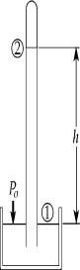**P14.9** (a) To find the height of the column of wine, we use



then



ANS. FIG. P14.9

(b) 

**P14.10** (a) We can directly write the bottom pressure as *P* = *P*0+ *ρgh*, or we can say that the bottom of the tank must support the weight of the water:

*PA − P*0*A* = *m*water*g* = *ρVg* = *ρAhg*

which gives again



(b) Now, the bottom of the tank must support the weight of the whole contents:

*P*b*A − P*0*A* = *m*water*g + Mg* = *ρVg + Mg* = *ρAhg + Mg*

and this gives

*P*b= *P*0+ *ρhg* + *Mg*/*A*

Then



Section 14.4 Buoyant Forces and Archimedes’s Principle

**P14.11** Refer to Figure P14.11. We observe from the left-hand diagram,



and from the right-hand diagram,



which gives



where the buoyant force is

*B* = *m*water *g* = *ρ*w*V*object *g*

Now the density of the object is





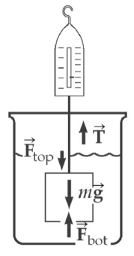**P14.12** (a) We start with 

Taking 

 and *h* = 5.00 cm,

we find 

ANS. FIG. P14.12

For *h* = 17.0 cm, we get



Since the areas of the top and bottom are



we find



and 

(b) The tension in the string is the scale reading:

*T* = *Mg − B*

where



and



Therefore,



(c) 

which is equal to *B* found in part (b).

**P14.13** (a) The buoyant force of glycerin supports the weight of the sphere which is supported by the buoyant force of water.





(b) The buoyant force from the water supports the weight of the sphere:







**P14.14** (a)  



(b) The oil pushes  on each side of the block.

(c) The string tension increases. The water under the block pushes up on the block more strongly than before because the water is under higher pressure due to the weight of the oil above it.

(d) The pressure of the oil’s weight on the water is *P* = *ρ*oil*gh,* where *h* is the height of the oil. This pressure is transmitted to the bottom of the block, so the extra upward force on the block is *F*oil= *PA* = *ρ*oil*ghA* = *ρ*oil*g*∆*V*, where ∆*V* = *hA* is the volume of the block below the top surface of the oil.

The force from the oil and the buoyant force of water balance the tension and the weight of the block:



The ratio of *F*oil and *B* are





The additional fraction of the block’s volume below the top surface of the oil is 

**P14.15** (a) While the system floats, , or



When ,  giving



(b) If the total weight of the block + steel system is reduced, by having  a smaller buoyant force is needed to allow the system to float in equilibrium. Thus, the block will displace a smaller volume of water and will be only partially submerged in the water.

(c) The block is fully submerged when *m*steel = 0.310 kg. The mass of the steel object can increase slightly above this value without causing it and the block to sink to the bottom. As the mass of the steel object is gradually increased above 0.310 kg, the steel object begins to submerge, displacing additional water, and providing a slight increase in the buoyant force. With a density of about eight times that of water, the steel object will be able to displace approximately 0.310 kg/8 = 0.039 kg of additional water before it becomes fully submerged. At this point, the steel object will have a mass of about 0.349 kg and will be unable to displace any additional water. Any further increase in the mass of the object causes it and the block to sink to the bottom. In conclusion, 

**P14.16** Let *A* represent the horizontal cross-sectional area of the rod, which we presume to be constant. The rod is in equilibrium:





The density of the liquid is 

**P14.17** We use the result of Problem 14.16. For the rod floating in a liquid of density 0.98 g/cm3,



For floating in the dense liquid,



(a) By substitution, and suppressing units,



(b) Substituting back,



(c) 

**P14.18** (a) We can estimate the total buoyant force of the 600 toy balloons as



(b) We estimate the net upward force by applying Newton’s second law in the vertical direction:



This net force was sufficient to lift Ashpole, his parachute, and other supplies.

(c) Atmospheric pressure at this high altitude is much lower than at Earth’s surface , so the balloons expanded and eventually burst.

**\*P14.19 Conceptualize** The diagram below shows the physical situation described in the problem, with the token resting on a flat surface and providing enough mass to keep the system from rising upward in the air. If the token is close to the minimum value required and the balloon is tied to the edge of the token, the force from the string can exert a torque on the token so that it stands upright as shown in the diagram.

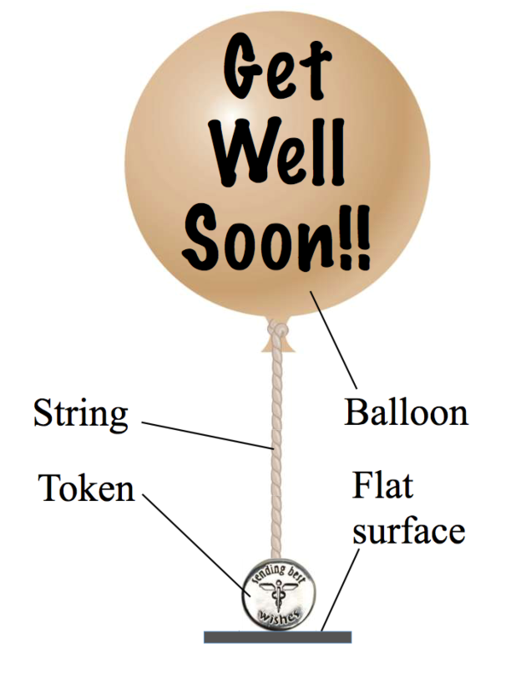

**Categorize** Because the system of the balloon, string, and token does not move, we model it as a *particle in equilibrium.*

**Analyze** The diagram below shows the physical system with the forces acting on the system added: the weight of the balloon envelope and the enclosed helium, the weight of the string, and the weight of the token. The two upward forces on the system are the buoyant force on the balloon and the normal force from the flat surface on the token.

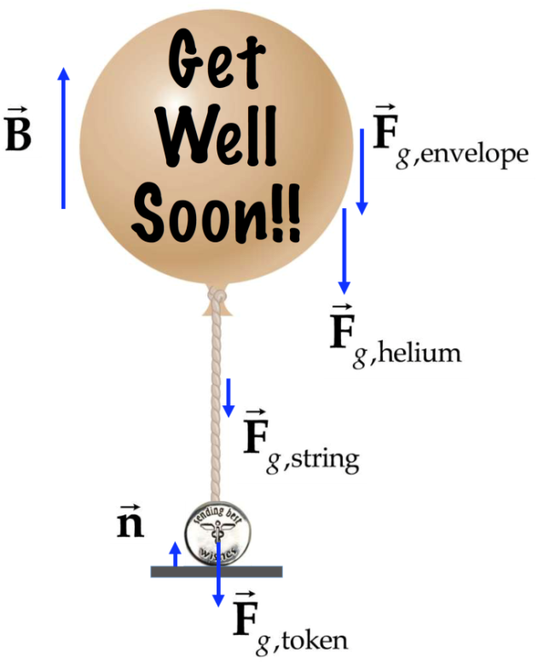

From the particle in equilibrium model, write the force equilibrium equation for the system:

 (1)

Substituting components in the *y* direction for each force in Equation (1) gives

 (2)

For each of the gravitational forces in Equation (2), substitute the product of the appropriate mass and *g*. In addition, to find the *minimum* required mass of the token, we imagine that the normal force  on the token just goes to zero. Now we have

 (3)

Solve Equation (3) for the mass of the token:

 (4)

Substitute in Equation (4) for the buoyant force and the mass of the helium:



Substitute numerical values:



**Finalize** The 10.0-g token would not be sufficient to hold this balloon down, so you would need to select the 20.0-g token. In this case, there would be a small upward normal force on the token from the flat surface. (If the air temperature were to drop to 15°C, however, the density of air would increase to 1.225 kg**/**m**3**, and a similar calculation yields *m*token= 20.6 g. So, if there is a possible drop in temperature to 15°C, the 30 g token would be a better bet.

*Answer:* 20.0 g

Section 14.5 Fluid Dynamics

**P14.20** (a) The cross-sectional area of the hose is



and the volume flow rate (volume per unit time) is

*A*v = 25.0 L/1.50 min

Thus,



(b)  or 

Then from the equation of continuity, , we find



**P14.21** (a) Power is the rate of energy flow as a function of time:



(b) The power delivered by the Grand Coulee dam is



Section 14.6 Bernoulli’s Equation

**P14.22** (a) Between sea surface and clogged hole:







The air on the back of his hand pushes opposite the water, so the net force on his hand is



 toward Holland

(b) Now, Bernoulli’s equation gives





The volume rate of flow is



One acre–foot is 

Requiring 

**P14.23** (a) The cross-sectinal area is the same everywhere, so the speed is the same everywhere:





(b) The volume flow rate is 



**P14.24** (a) The volume flow rate is the same at the two points: *A*1v1= *A*2v2:



We assume the tubes are at the same elevation:



where the pressure is in pascals.

The volume flow rate is



(b) For 



(c) With pressure difference 2 times larger, the flow rate is larger by the square root of 2:



**P14.25** (a) For upward flight of a water-drop projectile from geyser vent to fountain–top, 

Then  and 

(b) Between geyser vent and fountain-top:



Air is so low in density that very nearly  Then,





(c) 

(d) Between the chamber and the fountain-top: 



**\*P14.26** **Conceptualize** Consider the two plans shown, one with the buildings offset from each other and the other with the buildings right next to each other. In which case is there a narrower channel of air between the buildings?

**Categorize** As noted in the problem statement, we are concerned with the Bernoulli effect applied to moving air in this problem.

**Analyze** (a) You will have a difficult time formulating a defense for your client based on the last-minute substitution of the plans. Plan (ii) is more dangerous in terms of popping windows. There is a long, narrow channel of air between the buildings. According to the continuity equation for fluids, the wind will rush through this constricted channel at a very high speed. From Bernoulli’s principle, this air will exert low pressure on the outer surfaces of the windows, causing them to possibly pop out due to the higher pressure of the interior air. In Plan (i), there is a narrow channel only between the corners of the buildings. Generally, there is structural material at the corners of buildings, rather than windows, so the possibility of window popping is reduced compared to Plan (ii).

(b) Let’s apply Bernoulli’s principle to this situation, defining point 1 as the inner surface of a window and point 2 as the outer surface in the wind:

 (1)

The inner and outer surfaces of the window are at the same height *y*, and the speed of the interior air is zero, so we can simplify the equation as follows:

 (2)

The net force on the window is outward and given by

 (3)

Substitute numerical values:



(c) Substitute modified numerical values into Equation (3):



**Finalize** Note that the net force on a window is proportional to the *square* of the wind speed, so doubling the wind speed, as we did on part (c), causes the force to increase by a factor of *four*. The narrow channel in Plan (ii) in part (a) can easily double the wind speed, causing this plan to be very dangerous. So what can the owner do, now that the project is already built? All of the windows on the sides of both buildings facing each other need to be replaced with reinforced windows and mounts that can withstand the high pressure difference. Industry standards allow for a failure rate for windows, so ensuring that no window will ever pop out is impossible.

*Answers:* (a) Answers will vary, but will depend on the Bernoulli effect. (b) 452 N (c) 1.81 × 103

Section 14.7 Flow of Viscous Fluids in Pipes

**\*P14.27** Solution missing

**\*P14.28** Solution missing

**\*P14.29** Solution missing

Section 14.8 Other Applications of Fluid Dynamics

**P14.30** (a) Force balance requires that







(b) 

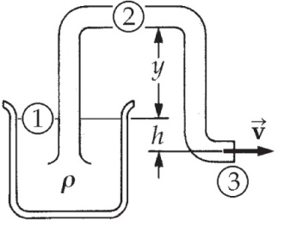**P14.31** (a) We use Bernoulli’s equation,



which gives 

ANS. FIG. P14.31

If *h* = 1.00 m, then 

(b) Again, from Bernoulli’s equation,



Since 



Since  the greatest possible siphon height is given by



**Additional Problems**

**P14.32** The water exerts a buoyant force on the air, given by



The weight of the air is



To transport the air down at constant speed requires a downward force *D* in +98.0 N – 0.235 N – *D* = 0, *D* = 97.8 N, and work



**P14.33** (a) 

(b) When the balloon comes into equilibrium, we must have



where *B* is the buoyant force, *Fb* the weight of the balloon, *F*He the weight of the helium, and *Fs* the weight of the segment of string above the ground.

(c) Write expressions for each of the terms in the force equation:



and  where 

Therefore, we have



or 

(d) 

(e) 

**P14.34** The “balanced” condition is one in which the apparent weight of the body equals the apparent weight of the weights. This condition can be written as



where *B* and *B*′ are the buoyant forces on the body and weights, respectively. The buoyant force experienced by an object of volume *V* in air equals



so we have  and



Therefore, 

**P14.35** Consider spherical balloons of radius 12.5 cm containing helium at STP and immersed in air at 0°C and 1 atm. If the rubber envelope has mass 5.00 g, the upward force on each is



If your weight (including harness, strings, and submarine sandwich) is



you need this many balloons:



**P14.36** Let the ball be released at point 1, enter the liquid at point 2, attain maximum depth at point 3, and pop through the surface on the way up at point 4.

(a) Energy conservation for the fall through the air:





(b) 

The gravitational force is

*mg* = (2.10 kg)(9.80 N/kg) = 20.6 N down

and the buoyant force is



(c) The buoyant force is greater than the gravitational force.



We choose to use the work-kinetic energy theorem.







**P14.37** (a)  gives 



(b) For Mt. Everest, 29 300 ft = 8.88 km, 

**P14.38** (a)The blood flowing through the artery is similar to water flowing through a pipe. We substitute numerical values into the equation for the Reynolds number:



Because this result is less than 2 300, the flow is laminar.

(b) Denote the situation in part (a) using subscripts 1. In the expression for the Reynolds number for the capillary, which we denote as situation 2, incorporate the continuity equation for fluids as the blood flows into the smaller blood vessel:



Solve the resulting equation for the radius of the capillary:



Substitute numerical values, including a Reynolds number representing turbulent flow:



(c) 

**P14.39** Let *f* represent the fraction of the volume *V* occupied by zinc in the new coin. We have *m =* *ρV* for both coins:



and 

By substitution,



and again substituting to eliminate the volume,



**P14.40** (a) The torque is



From ANS. FIG. P14.40,



ANS. FIG. P14.40

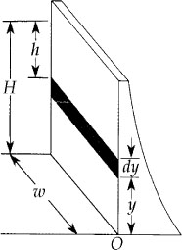 (b) The total force is given as 

If this were applied at a height yeff such that the torque remains unchanged, we have

 and 

(d) The same net force acts on the ball over the same distance as it moves down and as it moves up, to produce the same speed change. Thus v4 = 

(e)  because the ball moves with the same range of speeds over equal distance intervals.

(f) 

**P14.41** (a) Since the upward buoyant force is balanced by the weight of the sphere,



In this problem, at 20.0°C, and *R* = 1.00 cm, so we find



(b) Following the same procedure as in part (a), with  at 30.0°C, we find



(c) When the first sphere is resting on the bottom of the tube,  where *n* is the normal force.

Since 



**P14.42** Take point  at the free water surface in the tank and point  at the bottom end of the tube:



The volume flow rate is  Then 

**\*P14.43** **Conceptualize** The force from the water pressure will act outward on the hatch, which will tend to open it. The latch must supply sufficient force inward at the bottom of the hatch to counter this effect.

**Categorize** We wish the hatch not to rotate around the hinges, so we model it as a *rigid object in equilibrium.*

**Analyze** In Figure P14.43, the force from the water pressure will create a positive torque on the hatch about the hinges, while the latch will provide a negative torque. From the rigid object in equilibrium model applied to the hatch,

 (1)

Substitute for the torque applied by the latch:

 (2)

To evaluate the torque applied by the water, we need to add some geometry to Figure P14.43. Identify a horizontal strip on the hatch and add a variable *y* to represent the height of the strip above the bottom of the tank:

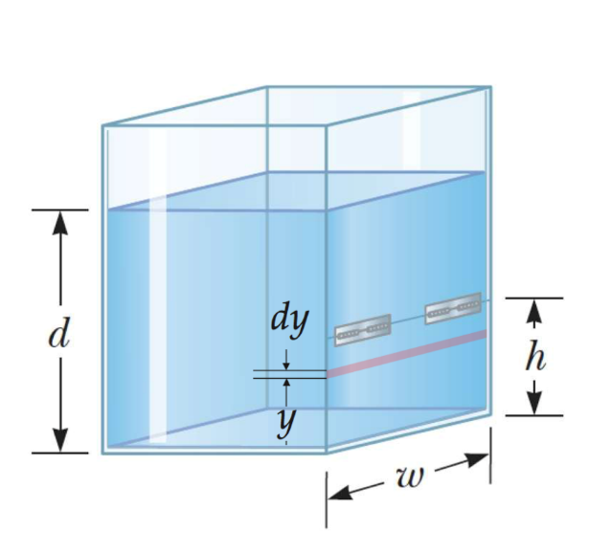

Now, the torque applied by the force due to the pressure of the water on the strip about the hinges is expressed as follows:



Integrate this expression over the range from *y* = 0 to *y* = *h*:



Substitute Equation (4) into Equation (2):

 (5)

Substitute numerical values:



**Finalize** This value will guide you as to which type of latch to purchase. Notice that we did not include the effect of air pressure on the hatch. That is due to the fact that a force due to air pressure pushes inward on the outer surface of the hatch, but the pressure at various depths on the inner surface is increased by the air pressure above the water. Therefore, the effects of the air on the inner and outer surfaces cancel and we only need to consider the force on the hatch due to the water.

Answer: 18.1 N

**\*P14.44** **Conceptualize** The force from the water pressure will act outward on the hatch, which will tend to open it. The latch must supply sufficient force inward at the bottom of the hatch to counter this effect.

**Categorize** We wish the hatch not to rotate around the hinges, so we model it as a *rigid object in equilibrium.*

**Analyze** In Figure P14.43, the force from the water pressure will create a positive torque on the hatch about the hinges, while the latch will provide a negative torque. From the rigid object in equilibrium model applied to the hatch,

 (1)

Substitute for the torque applied by the latch:

 (2)

To evaluate the torque applied by the water, we need to add some geometry to Figure P14.43. Identify a horizontal strip on the hatch and add a variable *y* to represent the height of the strip above the bottom of the tank:

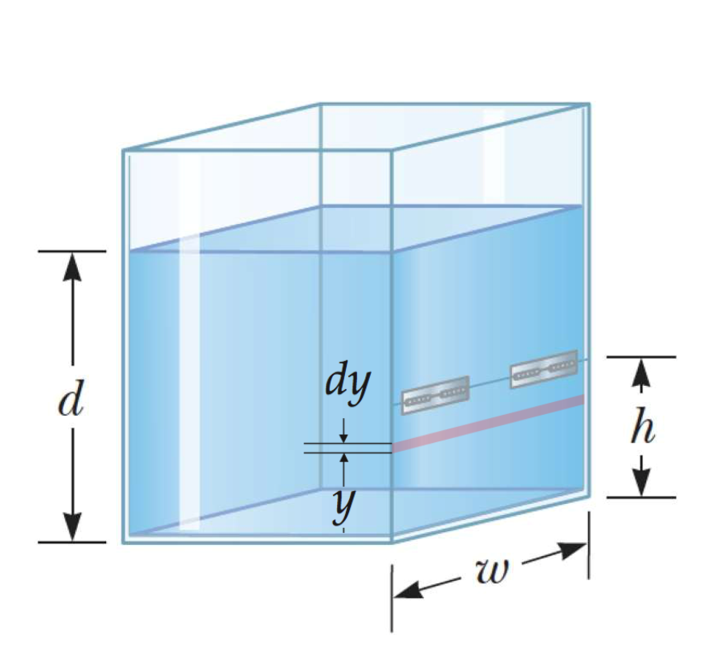

Now, the torque applied by the force due to the pressure of the water on the strip about the hinges is expressed as follows:



Integrate this expression over the range from *y* = 0 to *y* = *h*:



Substitute Equation (4) into Equation (2):

 (5)

**Finalize** This value will guide you as to which type of latch to purchase. Notice that we did not include the effect of air pressure on the hatch. That is due to the fact that a force due to air pressure pushes inward on the outer surface of the hatch, but the pressure at various depths on the inner surface is increased by the air pressure above the water. Therefore, the effects of the air on the inner and outer surfaces cancel and we only need to consider the force on the hatch due to the water.

*Answer:*

**P14.45** The disk (mass *M* = 10.0 kg, radius *R* = 0.250 m) has moment of inertia  The disk slows from  rev/min to  in time interval  Its angular acceleration is



Frictional torque from the brake pad slows the wheel. Friction has moment arm *d* = 0.220 m. The relation between friction and angular acceleration is



The normal force and coefficient of friction  between the brake pad and the disk determine the amount of friction. We can write an expression for the normal force:



The pressure of the brake fluid acting on a piston of area *A* (diameter   
*D* = 5.00 cm, radius *r* = *D*/2 = 0.0250 m) produces the normal force that the brake pad exerts on the disk. The pressure in the brake fluid is





**P14.46** (a) Since the pistol is fired horizontally, the emerging water stream has initial velocity components of  Then,  with *ay* = −*g*, gives the time of flight as



(b) With *ax* = 0, and v0x = vnozzle, the horizontal range of the emergent stream is  where t is the time of flight from above. Thus, the speed of the water emerging from the nozzle is



(c) From the equation of continuity, *A*1v1 = *A*2v2, the speed of the water in the larger cylinder is  or



(d) The pressure at the nozzle is atmospheric pressure, or 

(e) With the two cylinders horizontal, *y*1 = *y*2 and gravity terms from Bernoulli’s equation can be neglected, leaving



so the needed pressure in the larger cylinder is



or



(f) To create an overpressure of  in the larger cylinder, the force that must be exerted on the piston is



**P14.47** Energy for the fluid-Earth system is conserved.



**P14.48** (a) For diverging streamlines that pass just above and just below the hydrofoil, we have



Ignoring the buoyant force means taking 



The lift force is 

(b) For liftoff,



The speed of the boat relative to the shore must be nearly equal to this speed of the water below the hydrofoil relative to the boat.

**Challenge Problems**

**P14.49** The incremental version of  is 

We assume that the density of air is proportional to pressure,

or . Combining these two equations we have



Integrating both sides,



gives 

Defining  then gives 

**P14.50** Assume the top of the barge without the pile of iron has height *H*0 above the surface of the water. When a mass of iron *M*Fe is added to the barge, the barge sinks a distance  until the buoyant force from the water equals the additional weight of the iron. The barge is a square with sides of length *L*, so the volume of displaced water is  and the buoyant force supporting the extra weight is



where ** is the density of water.

The scrap iron pile has the shape of a cone, and the volume of a cone of base radius *R* and central height *h* is  therefore, the mass of the iron is  where  is the density of iron. We find the distance the barge sinks with a pile of iron:



If the iron is piled to a height *h,* the barge will sink by the distance  so the distance from the water level to the top of the iron pile is 

For the situation of the problem, side *L* = 2*r*, and the initial conical pile of scrap iron has radius *R* = *r* and height is *h* = *r*. The distance the barge sinks is



and the height of the top of the pile above the water is

**

For  and  this expression becomes



This distance is too large to allow the barge to go under the bridge:



When the pile is reduced to a height *h*′, but still with the same base radius *R* = *r*, the distance the barge sinks is



The height of the top of the pile above the water is now



but this means the top of the pile is now higher! To check this, recall that the height of the pile is reduced, so 





which is true.



|  |
| --- |
| **ANSWERS TO QUICK-QUIZZES** |

**1.** (a)

**2.** (a)

**3.** (c)

**4.** (b) or (c)

**5.** (a)

|  |
| --- |
| **ANSWERS TO EVEN-NUMBERED PROBLEMS** |

**P14.2** (a) ~4 × 1017 kg/m3; (b) See P14.2 for the full description.

**P14.4** The situation is impossible because the longest straw Superman can use and still get a drink is less than 12.0 m.

**P14.6** 2.71 ×105 N

**P14.8** (a) 14.7 kPa, 0.015 5 atm, 11.8 m; (b) Blockage of the fluid within the spinal column or between the skull and the spinal column would prevent the fluid level from rising.

**P14.10** (a) *P* = *P*0 + *ρgh*; (b) *Mg*/A

**P14.12** (a) 4.9 N down, 16.7 N up (b) 86.2 N (c) By either method of evaluation, the buoyant force is 11.8 N up.

**P14.14** (a) *B* = 25.0 N; (b) horizontally inward; (c) The string tension increases. The water under the block pushes up on the block more strongly than before because the water is under higher pressure due to the weight of the oil above it; (d) 62.5%

**P14.16** See P14.16 for the full derivation.

**P14.18** (a) 3.7 kN; (b) 1.9 kN; (c) Atmospheric pressure at this high altitude is much lower than at the Earth’s surface

**P14.20** (a) 0.471 m/s; (b) 4.24 m/s

**P14.22** (a) 2.28 N toward Holland (b) 1.74 × 106 s

**P14.24** (a)  where  is in pascal; (b) 0.305 L/s;   
(c) 0.431 L/s

**P14.26** (a) Answers will vary, but will depend on the Bernoulli effect. (b) 452

N (c) 1.81 × 103 N

**P14.28** [Solution missing]

**P14.30** (a) 6.80 × 104 Pa; (b) Higher. With the inclusion of another upward force due to deflection of air downward, the pressure difference does not need to be as great to keep the airplane in flight.

**P14.32** 1.01 kJ

**P14.34** See P14.34 for full description.

**P14.36** (a) 8.04 m/s; (b) The gravitational force and the buoyant force; (c) The net upward force on the ball brings it downward motion to a stop,   
4.18 m; (d) 8.04 m/s; (e) The time intervals are equal; (f) See P14.36(f) for a full conceptual argument.

**P14.38** (a) See P14.38(a) for full description; (b) 2.66 × 10–3 m; (c) The situation in the human body is not represented by a large artery feeding into a single capillary as in part (b). See P14.38(c) for full explanation.

**P14.40** (a)  (b) 

**P14.42** See P14.42 for the full answer.

**P14.44** 

**P14.46** (a) 0.553 s; (b) 14.5 m/s; (c) 0.145 m/s; (d) *P*2 = 1.013 × 105 Pa;   
(e) 2.06 × 105 Pa; (f) 33.0 N

**P14.48** (a) The lift force is  (b) The speed of the boat relative to the shore must be nearly equal to this speed of the water below the hydrofoil relative to the boat.

**P14.50** The situation is impossible because lowering the height of the iron pile on the barge while keeping the base radius the same results in the top of the pile rising higher above the water level.